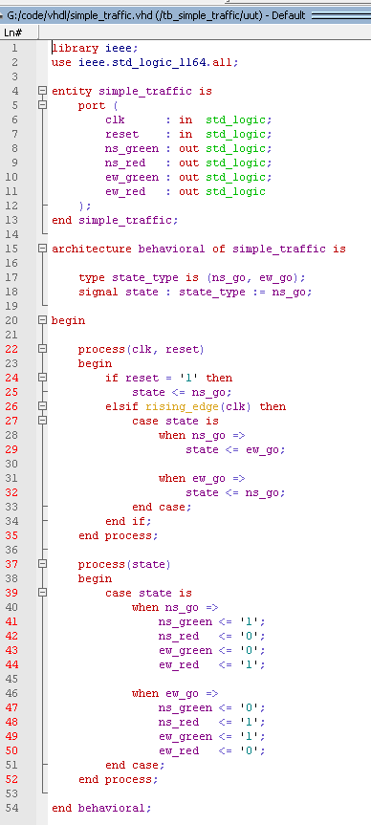
Program 1: VHDL Code for Simple Traffic Light Controller
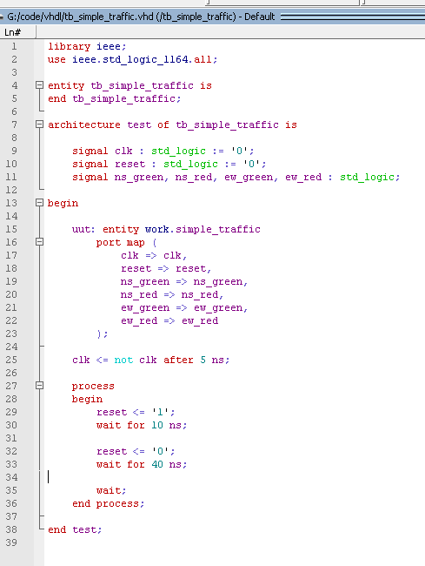
Program 2: VHDL Testbench for Simple Traffic Light Controller
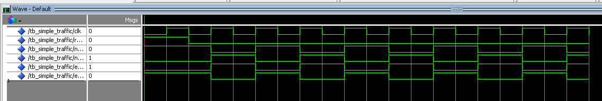
Testbench Output: Simulation Waveform of Simple Traffic Light Controller

